Name : Rushikesh Krishna Daund

**Assignment no 1**

1. Create an application for Bank to perform below operations

1. Create account

Name

Account no {Unique}

Balance

Address

2. Deposit amount (input: account no, amount)

3. Withdraw amount (input: account no, amount)

4. Display account information

5. Update account Name, Address {input account no}

Expectations:

- use OOPs concepts accordingly

- implement the validations around operations

- take inputs from user for choice then for operation

- Program should exit only when user choice matches the exit

Code :-

import java.util.*;

import java.text.*;

class Banking

{

String account_no;

String name="",address="";

float balance;

public void create_acc(String user_name,String ac_address)

{

account_no = new DecimalFormat("0000000000").format(new Random().nextInt(999999));

address = ac_address;

name = user_name;

System.out.println("account has been created ..");

}

public void deposit(String ac_no,float credit_bal)

{

if(account_no==ac_no)

{

balance = balance + credit_bal;

System.out.println("your balance is credited Successfully ");

}

else

{

System.out.println("operation fail please try again");

}

}

public void debit(String ac_no,float debit_bal)

{

if(account_no==ac_no)

{

balance = balance - debit_bal;

System.out.println("your balance is debited Successfully ");

}

else

{

System.out.println("operation fail please try again");

}

}

public void display()

{

System.out.println("Account Holder Name : - "+name);

System.out.println("Account Holder Address : - "+address);

System.out.println("Account Number : - "+account_no);

System.out.println("Account Available Balance : - "+balance);

}

public void info_update(String N1,String A1)

{

name = N1;

address = A1;

}

}

public class Banks {

public static void main(String[] args) {

int choice;

float bals;

String name,address,ac_no;

Scanner s1 = new Scanner(System.in);

Banking b1 = new Banking();

System.out.println("enter account holder name ");

name = s1.nextLine();

System.out.println("enter account holder address");

address = s1.nextLine();

b1.create_acc(name, address);

do{

System.out.println("\n \n welcome "+name+ ".....!");

System.out.println("press 1 for deposit amount ");

System.out.println("press 2 for view information");

System.out.println("press 3 for Withdraw amount ");

System.out.println("press 4 for update name & Address");

System.out.println("press 5 for exit Thank you for banking with us...! ");

System.out.println("\n \n enter you choice ");

choice = s1.nextInt();

switch(choice)

{

case 1:

System.out.println("enter account no ");

ac_no = s1.next();

System.out.println("enter amount ");

bals = s1.nextFloat();

b1.deposit(ac_no, bals);

break;

case 2:

System.out.println("your information");

b1.display();

break;

case 3:

System.out.println("enter account no ");

ac_no = s1.next();

System.out.println("enter amount ");

bals = s1.nextFloat();

b1.debit(ac_no, bals);

break;

case 4:

System.out.println("enter name ");

name = s1.nextLine();

System.out.println("enter address ");

address = s1.nextLine();

b1.info_update(name, address);

break;

case 5:

break;

default:

System.out.println("Please enter correct choice ");

break;

}

System.out.println("Thank you banking with us...!");

}while(true);

}

}

Output:

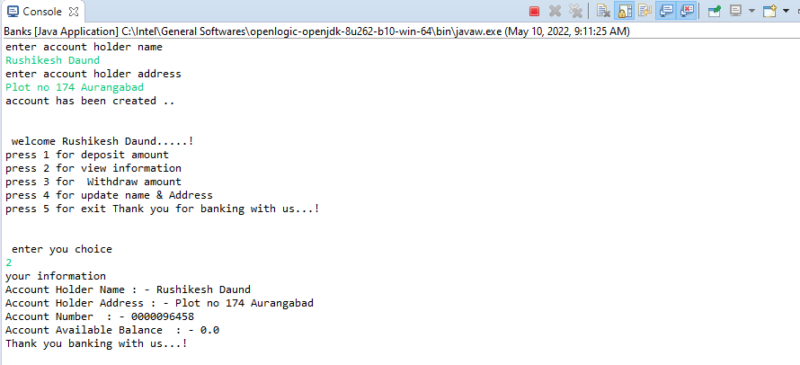

2. Create an application to calculate difference between two input dates.

Example,

Input1: 01 March 2000 (day-Month-year)

Input2: 16 August 2021 (day-Month-year)

Output:

Difference between two input dates is 21 years 5 months 15 days.

Expectations:

- implement required validations on input

Code:-

import java.text.SimpleDateFormat;

import java.text.ParseException;

import java.util.Date;

import java.util.Scanner;

class DateandTime {

static void diff(String join_date, String leave_date)

{

SimpleDateFormat obj = new SimpleDateFormat("dd-mm-yyyy");

try {

Date date1 = obj.parse(join_date);

Date date2 = obj.parse(leave_date);

long time_difference = date2.getTime() - date1.getTime();

long days_difference = (time_difference / (1000*60*60*24)) % 365;

long years_difference = (time_difference / (1000l*60*60*24*365));

System.out.print(

"Difference "

+ "between two dates is: ");

System.out.println(

""

+ years_difference

+ " years, "

+ days_difference

+ " days"

);

}

// Catch parse exception

catch (ParseException excep) {

excep.printStackTrace();

}

}

// Main class

public static void main(String[] args)

{

// Set values for both dates

Scanner obj = new Scanner(System.in);

String join = obj.nextLine();

String leave = obj.nextLine();

diff(join, leave);

}

}

3. Write a program to find length of longest consecutive sequence in array of integers?

Given an unsorted array of integers, find the length of the longest consecutive elements sequence.

Example,

Given [100, 4, 200, 1, 3, 2],

The longest consecutive elements sequence is [1, 2, 3, 4]. Return its length: 4

Code:-

**import** java.util.*;

**public** **class** SortingandSwaping {

**public** **static** **void** main(String[] args) {

**int** n;

Scanner obj = **new** Scanner(System.***in***);

System.***out***.println("enter size of array");

n = obj.nextInt();

**int** nums[]=**new** **int**[n];

**for**(**int** i=0;i<n;i++)

{

nums[i] = obj.nextInt();

}

System.***out***.println("Original array length: "+nums.length);

System.***out***.print("Array elements are: ");

**for** (**int** i = 0; i < nums.length; i++)

{

System.***out***.print(nums[i]+" ");

}

System.***out***.println("\nThe new length of the array is: "+*longest_sequence*(nums));

}

**public** **static** **int** longest_sequence(**int**[] nums) {

**final** HashSet<Integer> h_set = **new** HashSet<Integer>();

**for** (**int** i : nums) h_set.add(i);

**int** longest_sequence_len = 0;

**for** (**int** i : nums) {

**int** length = 1;

**for** (**int** j = i - 1; h_set.contains(j); --j) {

h_set.remove(j);

++length;

}

**for** (**int** j = i + 1; h_set.contains(j); ++j) {

h_set.remove(j);

++length;

}

longest_sequence_len = Math.*max*(longest_sequence_len, length);

}

**return** longest_sequence_len;

}

}

Output

